**Project Plan, Team Charter**

**Boutique Recruitment**

**JC Consulting**

|  |  |
| --- | --- |
| Industry Partner | JC Consulting |
| Primary Instructor | Anjana Shah |
| Team Member | Abdallahman Habyarimana – 101087205 |
| Team Member | Anushka Aggarwal – 101195651 |
| Team Member | Karanjot Singh- 101195883 |
| Team Member | Renata Moura - 101096098 |
| Team Member |  |

Document Revision History

|  |  |
| --- | --- |
| Revision # | Date |
| Revison 1 | 10/11/2018 |

Contents

1. Executive Summary 3

2. Project Approvers, Reviews and Distribution List 3

3. Scope 3

4. Deliverables 4

5. Assumptions 4

6. Dependencies 5

7. Risk Management 5

8. Communication 5

9. Task Listing (WBS- Work Breakdown Structure) 7

10. Gantt Chart 8

11. Milestones 9

12. RAM – Responsibility Assignment Matrix 10

13. Approval 10

# 1. Executive Summary

The following describes the project to be executed.

|  |  |
| --- | --- |
| Objective | Develop a web system to establish a consulting recruitment process, and onboarding processes |
| Corporate Goals Addressed | * Facilitates coordination and information sharing both internal and external to the participating involved. * Enhances the ability and effectiveness of staff to perform their jobs * Is easy to use. * Eliminate redundant data entry throughout the organization. |
| Planned Start Date | Sep 2018 |
| Planned End Date | Apr 2019 |

# 2. Project Approvers, Reviews and Distribution List

Approvers, reviewers and distribution list

|  |  |  |  |
| --- | --- | --- | --- |
| Project Role | Name | E-mail | Date |
| Sponsor | Tyler Krimmel | [tkrimmel@georgebrown.ca](mailto:tkrimmel@georgebrown.ca) |  |
| Team Member | Karanjot Singh | [Karanjot.-@georgebrown.ca](mailto:Karanjot.-@georgebrown.ca) |  |
| Team Member | Anushka Aggarwal | [Anushka.Aggarwal@georgebrown.ca](mailto:Anushka.Aggarwal@georgebrown.ca) |  |
| Team Member | Abdallahman Habyarimana | [Abdallahman.Habyarimana@georgebrown.ca](mailto:Abdallahman.Habyarimana@georgebrown.ca) |  |
|  |  |  |  |
|  |  |  |  |

# 3. Scope

Define the sum total of all of its products and their requirements or features.

|  |  |
| --- | --- |
| In Scope | Out of Scope |
| Web interface | AI to evaluate candidates |
| Workflow process | Interview Process |
| Database structure |  |
|  |  |

# 4. Deliverables

This project will deliver the following.

|  |  |
| --- | --- |
| Deliverable | Description |
| Web interface | Web interface that allows the clients to input their job request |
| Workflow process | System that map the hiring process |
| Database structure | The database structure to save the process and reports |
|  |  |
|  |  |

# 5. Assumptions

This project makes the following assumptions;

* Required stakeholders are committed to fulfilling roles documented in the approved Project Plan
* The Project Plan may change as new information and issues are revealed
* It is assumed that the user is familiar with an internet browser and familiar with handling the keyboard and mouse.
* Failure to identify changes to draft deliverables within the time specified in the project timeline will result in project delays
* Since the application is a web-based application there is a need for the internet browser. It will be assumed that the users will possess decent internet connectivity.
* Failure to identify changes to draft deliverables within the time specified in the project timeline will result in project delays.
* The Project Plan may change as new information and issues are revealed.

# 6. Dependencies

The following are the internal and external dependencies that will have to be acknowledged and addressed;

* Browser Compatibility: System should be web-based.
* Internet : Internet must be available

# 7. Risk Management

|  |  |  |  |
| --- | --- | --- | --- |
| Potential Risk | Severity (H/M/L) | Likelihood (H/M/L) | Management Strategy |
| Estimated Project Schedule | High | High | Created comprehensive project timeline with frequent baseline reviews |
| Project Scope Creep | Low: Scope generally defined, subject to revision | Low | Scope initially defined in project plan, reviewed frequently by three groups (Project Manager and Steering Committee) to prevent undetected scope creep |
| Project Team’s Shared Work Experience creates poor working relationship | H: Some have not worked together before | High | Comprehensive Communications Plan |
| Change Management Procedures undefined | Medium: | Medium | Re-evaluate the plan and deliverables |
| Narrow Knowledge Level of Users | Medium: Knowledgeable of user area only | High | Assigned Project Manager(s) to assess global implications |

# 8. Communication

**Reporting**

The following reports will be produced;

|  |  |  |
| --- | --- | --- |
| Report | Audience | Frequency |
| Status Report | Project Team, Sponsor | Bi-weekly |
| Sprints | Project Team, Teacher | On demand |

**Meetings**

The following meetings/communication will be established;

|  |  |  |  |
| --- | --- | --- | --- |
| Meeting | Purpose | Attendees | Frequency |
| Planning**:** | Develop the project plan; assign roles and responsibilities; make decisions about how the project will be carried out. | Project Team | Once |
| Walk-through: | Read through the project plan and/or significant documentation to uncover problems and clarify information. | Project Team | Once |
| Problem Solving: | Solve problems that require several members of the team and/or management; generate alternative solutions. | Project Team | Weekly |
| Debrief: | Provide critical information to higher levels of management. Focus on goals, results, schedule; seek approval for next steps where appropriate. | Project Team | Weekly |
| Presentations: | Make a formal presentation to managers, stakeholders, and others about the results at the end of the project. | Project Team | On demand |
| Milestone: | Conduct formal reviews of progress against plan at critical points defined in the project plan when important interim steps are completed; present interim results. | Project Team | On demand |
| Problem Solving: | Solve problems that require several members of the team and/or management; generate alternative solutions. | Project Team | On demand |

# 9. Task Listing (WBS- Work Breakdown Structure)

The following resource proposal template summarizes the resource hours committed to this project, upon final approval of this document.

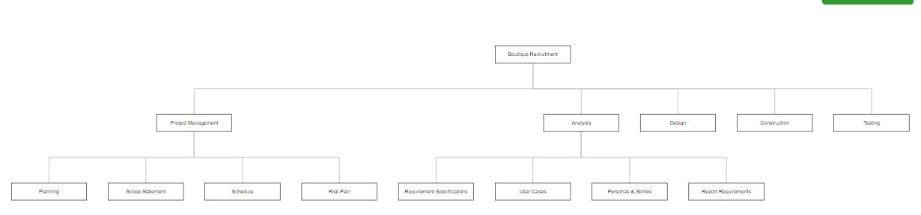

|  |  |  |  |  |
| --- | --- | --- | --- | --- |
| Reference | Name | | Duration | Dependency |
| A | Sprint 1: | |  |  |
| A.1 |  | Vision Document | 7 |  |
| A.2 |  | Business Requirements | 7 |  |
| A.3 |  | Personas & User Stories | 7 |  |
| B | Sprint 2: | | 7 | Sprint 1 |
| B.1 |  | Project Plan | 7 |  |
| B.2 |  | Team Charter | 7 |  |
| B.3 |  | Product Backlog | 7 |  |
| B.4 |  | Sprint Backlog | 7 |  |
| C | Sprint 3: | | 21 | Sprint 2 |
| C.1 |  | System Requirements, Analysis and Design | 21 |  |
| D | Sprint 4: | | 14 | Sprint 3 |
| D.1 |  | Wireframes/Prototype | 14 |  |
| D.2 |  | Technical Requirements | 14 |  |
| D.3 |  |  |  |  |
| E | Development Tasks: | |  |  |
| E.1 |  | Process definition/design | 15 |  |
| E.2 |  | Workflow functionalities/design | 20 | Process definition/design |
| E.3 |  | Feedback functionalities/design | 20 | Workflow functionalities/design |
| E.4 |  | Database definition/design | 10 | Home page design |
| E.5 |  | Home page design | 10 | Feedback functionalities/design |

# 10. Gantt Chart

Create a Gantt Chart from your Task Listing – Below is an example:

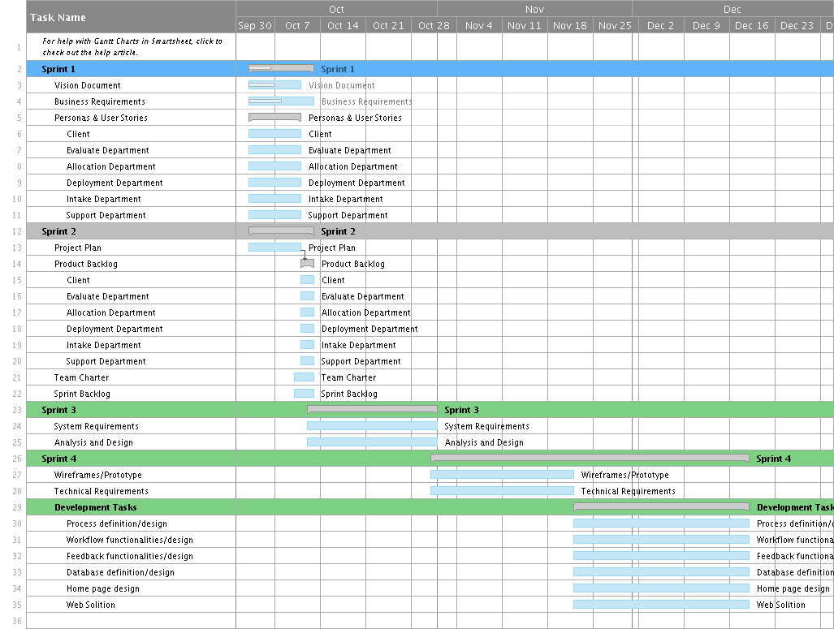

|  |  |  |  |  |  |  |  |  |  |  |  |  |  |
| --- | --- | --- | --- | --- | --- | --- | --- | --- | --- | --- | --- | --- | --- |
| Task Name | | | Weeks | | | | | | | | | | Complete |
| 1 | 2 | 3 | 4 | 5 | 6 | 7 | 8 | 9 | 10 |
| **Sprint 1** | | |  |  |  |  |  |  |  |  |  |  |  |
|  | Vision Document | |  |  |  |  |  |  |  |  |  |  | Completed |
|  | Business Requirements | |  |  |  |  |  |  |  |  |  |  |  |
|  | Personas & User Stories | |  |  |  |  |  |  |  |  |  |  |  |
|  |  | Client |  |  |  |  |  |  |  |  |  |  |  |
|  |  | Evaluate Department |  |  |  |  |  |  |  |  |  |  |  |
|  |  | Allocation Department |  |  |  |  |  |  |  |  |  |  |  |
|  |  | Deployment Department |  |  |  |  |  |  |  |  |  |  |  |
|  |  | Intake Department |  |  |  |  |  |  |  |  |  |  |  |
|  |  | Support Department |  |  |  |  |  |  |  |  |  |  |  |
| **Sprint 2** | | |  |  |  |  |  |  |  |  |  |  |  |
|  | Project Plan | |  |  |  |  |  |  |  |  |  |  |  |
|  | Product Backlog | |  |  |  |  |  |  |  |  |  |  |  |
|  |  | Client |  |  |  |  |  |  |  |  |  |  |  |
|  |  | Evaluate Department |  |  |  |  |  |  |  |  |  |  |  |
|  |  | Allocation Department |  |  |  |  |  |  |  |  |  |  |  |
|  |  | Deployment Department |  |  |  |  |  |  |  |  |  |  |  |
|  |  | Intake Department |  |  |  |  |  |  |  |  |  |  |  |
|  |  | Support Department |  |  |  |  |  |  |  |  |  |  |  |
|  | Team Charter | |  |  |  |  |  |  |  |  |  |  |  |
|  | Sprint Backlog | |  |  |  |  |  |  |  |  |  |  |  |
|  |  | Client |  |  |  |  |  |  |  |  |  |  |  |
|  |  | Evaluate Department |  |  |  |  |  |  |  |  |  |  |  |
|  |  | Allocation Department |  |  |  |  |  |  |  |  |  |  |  |
|  |  | Deployment Department |  |  |  |  |  |  |  |  |  |  |  |
|  |  | Intake Department |  |  |  |  |  |  |  |  |  |  |  |
|  |  | Support Department |  |  |  |  |  |  |  |  |  |  |  |
| **Sprint 3** | | |  |  |  |  |  |  |  |  |  |  |  |
|  | System Requirements | |  |  |  |  |  |  |  |  |  |  |  |
|  | Analysis and Design | |  |  |  |  |  |  |  |  |  |  |  |
| **Sprint 4** | | |  |  |  |  |  |  |  |  |  |  |  |
|  | Wireframes/Prototype | |  |  |  |  |  |  |  |  |  |  |  |
|  | Technical Requirements | |  |  |  |  |  |  |  |  |  |  |  |
| **Development Tasks** | | |  |  |  |  |  |  |  |  |  |  |  |
|  | Process definition/design | |  |  |  |  |  |  |  |  |  |  |  |
|  | Workflow functionalities/design | |  |  |  |  |  |  |  |  |  |  |  |
|  | Feedback functionalities/design | |  |  |  |  |  |  |  |  |  |  |  |
|  | Database definition/design | |  |  |  |  |  |  |  |  |  |  |  |
|  | Home page design | |  |  |  |  |  |  |  |  |  |  |  |
|  | Web Solution | |  |  |  |  |  |  |  |  |  |  |  |

# 11. Milestones

|  |  |  |
| --- | --- | --- |
| Major Activity or Milestone | Estimated Milestone Target date | Owner/Reviewer Team Members |
| Kick off | 09/26/2018 | Project Team / Sponsor |
| Sprint 01 | 10/12/2018 | Project Team |
| Sprint 02 | 10/12/2018 | Project Team |
| Sprint 03 | 10/31/2018 | Project Team |
| Sprint 04 | 11/21/2018 | Project Team |
| Website plan complete | 12/21/2018 | Project Team |
| Website design complete | 12/21/2018 | Project Team |
| Website construction complete | 12/21/2018 | Project Team |

# 12. RAM – Responsibility Assignment Matrix

Create a RAM from your Task Listing. A sample is shown below:

|  |  |  |  |  |  |  |
| --- | --- | --- | --- | --- | --- | --- |
| ***Project Team Responsibilities*** | | | | | | |
| Project Name: | Boutique Recruitment | | |  |  |  |
| Project Manager: | Renata Moura | |  |  |  |  |
|  |  |  |  |  |  |  |
| Task | Renata Moura | Abdallahman Habyarimana | Anushka Aggarwal | Karanjot Singh |  |  |
| Sprint 01 | P | S | S | S |  |  |
| Sprint 02 | P | S | S | S |  |  |
| System Requirements | S | P | S |  |  |  |
| Analysis and Design | S | P | S |  |  |  |
| Wireframes/Prototype | S | S | P |  |  |  |
| Technical Requirements | S | P | S |  |  |  |
| Testing | S | S | P |  |  |  |
| P = Primary S = Secondary | | | | |  |  |

# 13. Approval

The signatures below indicate their approval of the contents of this document.

|  |  |  |  |
| --- | --- | --- | --- |
| Project Role | Name | Signature | Date |
|  |  |  |  |
|  |  |  |  |
|  |  |  |  |
|  |  |  |  |
|  |  |  |  |
|  |  |  |  |

**TEAM CHARTER**

Multiple reasons exist for preparing a team charter. One is to document the team's purpose and clearly define individual roles, responsibilities, and operating rules. Next, it establishes procedures for both the team and management/industry partner on communicating, reporting, and decision-making procedures. It lays out a blueprint for conducting business for the acquisition and defines how the team works in an empowered manner, including setting out responsibility and authority. Finally it facilitates stakeholder buy in by including key members in the decision making process and obtaining their concurrence along the way.

The charter includes the following sections:

1. Purpose

(Describe the purpose for forming the team and the anticipated outcomes.)

2. Background

(Summarize the program or project the team is supporting, state how the team fits within the organizational structure, identify who are the users/customers of the program/project including external customers and stakeholders, sand describe special circumstances surrounding the project.)

3. Scope

(State the scope, mission, and objectives for the project and the team's role in achieving it. This is similar to preparing a mission need statement. Define the high level goals the team must accomplish.)

4. Team composition

(Identify the functional areas represented, the number of members from each, state who are core [essential] members versus support or advisory members and full or part time designation, and the anticipated time/resources commitments involved over the anticipated duration of the team.)

5. Team empowerment

(Define existing authority the team, by virtue of its individual membership, already possesses, additional authority needed to fully perform as envisioned by the team objectives, and level of empowerment requested.)

6. Team operations

(Describe team operational plans. This includes, for example, such activities as the team's decision-making processes, how changes in membership occur should the need arise, plans to establish "ground" or operating rules, relationships with other organizational entities or teams, logistical support, etc.)

7. Team Performance Assessment

(Document key areas of performance needed for team success along with means of measuring progress.)

8. Signature Page

(Each team member signs, agreeing to the contents and being held mutually accountable for adherence.)

​